# **Computer human interaction**

**Shopping application UX design fundamentals Created design in “Marvel” and done some evaluation**

Contents

Abstract summary: 3

Introduction: 3

Discuss conceptual modelling and how it applied to the design: 3

Universal design principles : 5

Universal design has principles such as: 6

Visibility: 6

Feedback: 7

Affordance: 8

Constraints: 9

Mapping**:** 11

Consistency: 13

The design can handle at least three types of human limitation /special needs: 15

Accessibility: 15

Usability: 15

Inclusion: 15

**Cognitive processes how can it affect in the application:** 15

Memory : 16

Attention: 16

Perceptions: 16

Conclusion: 16

Recommendation: 17

References 17

My final design : 18

# Abstract summary:

This summary demonstrates proper designing of the chosen application shopping Application design with multiple features which is user-friendly. Which helps user to buy the products online as per their convenience . This application provides multiple options that they can get deliver the products as per their requirement. This application makes the user experience far better than any other applications. The design includes the conceptual model, that how design will work it also include universal design principle from which the specific standards are mentioned like visibility, Feedback, Affordance, constraints and consistency of the design which help design of the application to be proper as per user experience.

# Introduction:

Human computer interaction is combining several branches of learning it aiming on the model of the computers. In detail it is interacting between user and computer. HCI has subsequently encompass nearly every types of IT models (Carroll, John M., 2016). This research shows that in what way individuals relates through computers and to which amount computers are or are not created for effective interface with human being. HCI comprises of three elements: The user, the computer, and how they both work out at the same time. The goals of HCI is to build manageable application that is well efficient and secure. I created one mobile application design which is all about shopping application. I created this application for the user who want to do instant shopping sitting at their home. This application helps user in many ways such as first and foremost it is user-friendly application which is easy to use. User will not get confuse or not put in any problem using this application it is also secure application. User will get the different deals by using this application they will also get the discount which they will not get into the store. It also benefits that it delivers right at user place. User also get the details of there order till there order will not reach to there place user can also track the order easily. In shopping application user can have multiple choice for their payment options they can give cash on delivery or pay online through there debit/credit cards or they also use PayPal, and which is really secure method for payment. Applications fonts and colour is clearly visible all the buttons are perfectly placed. This application is really crucial for every age Individual because it includes every stuff for shopping.

# Discuss conceptual modelling and how it applied to the design:

A conceptual model is a portrayal of a structure. Which is formed through architecture of concepts that can be useful to benefit person to recognize, to acknowledge or replicate the idea of model which is represents. It can also be the group of the concepts. The word “conceptual-modelling” can be used to assign the models that are compose beyond the “generalization procedure” or “Conceptualization procedure”. The conceptual models are generally use for abstruse portrayal of actuality in real world models. In short conceptual modelling is used to prepare the prototype of model design or an object in abstract way to the user. It can be used in a period of common process for software developing process and can be assign as “domain models”. It shows the relationship between the model system for example database entities showing process of model. It shows many kinds of relationship like 0ne-to-one, one-to-many and many-to-many.

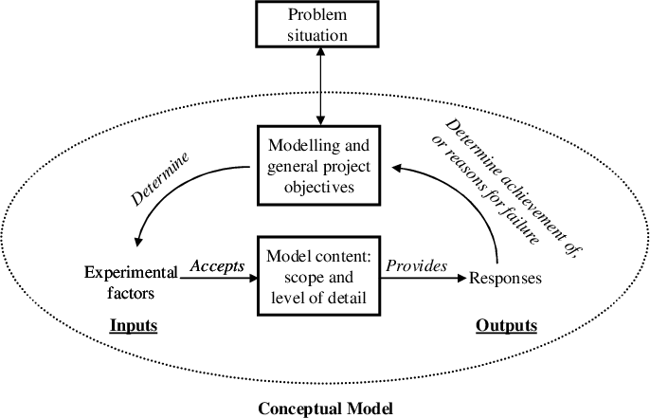

AS per my application design which is shopping application which is useful application for every person in there day to day life. On each and every occasion shopping application is used. So it having many related entities in the process of shopping application. For that I prepared conceptual diagram which represent the application process clearly . As per below diagram It Represents the whole process of online shopping so first and foremost user should have three utility provider to use the application which is user device, Internet provider and Electricity power provider .Than after all this process user can go to application platform and than view the items. User need to Register through sign-up and sign-in process after that user can start the purchase process easily through the application. last but not the least the delivery process get done and user get the online delivery easily at there place. This all process is same as conceptual model. In which user need to give some input to get successful output

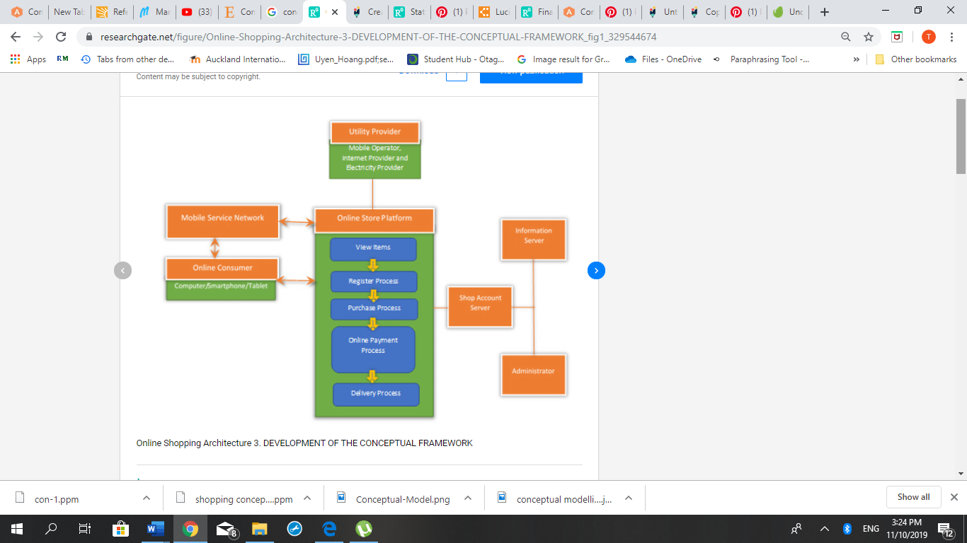

# Universal design principles :

The universal design is layout and combination of an surroundings in order to access, adopt and implied directed towards immense scope achievable by entirely all the people no matter what age, size or any person with disability. An surroundings will be accomplish towards to fit the demand of the people who intent to use it. This all indicated is not at all significant needs. For Considering betterment of less number of people. It is the one of the principle of better model. Suppose an element is usable, applicable, comfortable and get joy to use, each person will gain benefits.

# Universal design has principles such as:

## Visibility:

It means that In website or mobile applications end user can experience that all the option’s to be showed up properly, and recognize directly how to approach the system, as per the illustration practice perceptive icon which is demonstrate that there are further options.AS indicated this level is majorly essential as long as to consider mobile application framework, It’s necessary towards to conduct basic fragment about the data that clearly visible to lessening end user’s intellectual amount of load. Suppose object is not shown appropriate to the end user, There will be a great possibility that user will not able to remember about the features and how it going to be used. As per my application the sign in and sign out visibility is clearly seen and by this user will not get confuse user can easily sign in and sign out from the application

visual of the design is so clear and user would not make any efforts

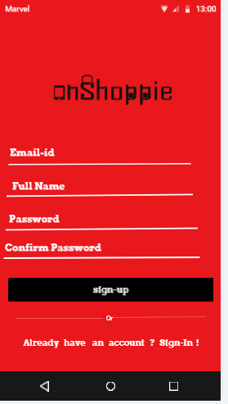

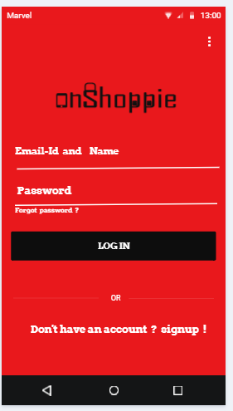

## Feedback:

Feedback means that there is requirement to get a few hints to the user, such as some kind of music, a rolling wheel, a revolving rainbow wheel, such a particular activity creates object. As per the example “Google chrome” undertake an enormous work for this such as if any search is done by user than it is loading a page. The small rotating round begin to work instantly when user click the enter. In such a manner that user gets an idea that object is proceeding. It drives speedily the activity until the page is almost gets load. It’s quite straightforward and useful feedback. Feedback Indicate the clear return such as the individual receive through operating several communications. It is the proof that the particular operations were accomplished. As it can be seen from the design that before placing order user suppose to sign in or sign up for the application than user can place their order. So user got feedback through this message , In second design it show that before placing the order if user want to change the address than user can change that address easily.

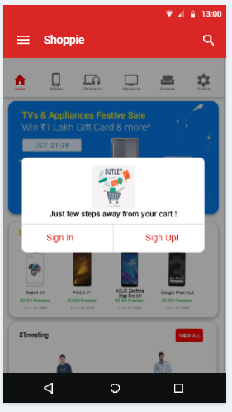

User got the message from the application to sign in or sign up to their account before selecting there order

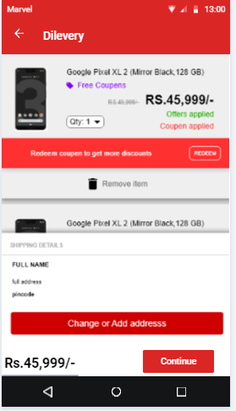

This feedback shows to the user that before placing orders if user want to change the address than user can change.

## Affordance:

Affordance is tie up among what object review that is related and by what means it is useable. For design architect, it is the process that if any individual look at some object that individual must recognize and by what means it practice it. As per example, web architect, affordance is even much more essential. End user need to declare by what means it will achieve info whatever user want from the application. Or than user will directly leave. Affordance could be anything fundamentally it is characteristics that shows by what method it can be used. If there is inadequacy for affordances than it makes an troublesome for user understanding. As shown below there is a search icon is use for searching anything from the application and it is easy for user to search directly from the search icon it also saves the time of the user

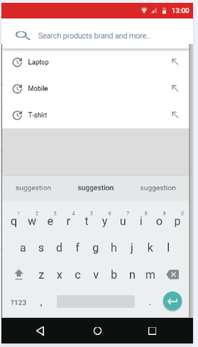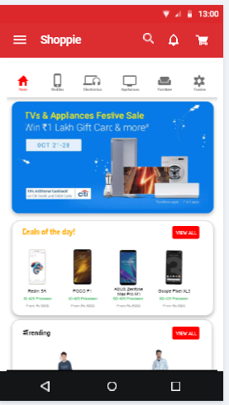

search icon

## Constraints:

Constraints are bar to the communication or attachment. A few constraints are understandable and real. As per example display screen size of the cell phone. suppose there is one webpage and having pictures that peeping user to the main page .it is easy for the end user to roll along the way to look at the following pictures. It is the part of the layout that it constrains. End user presenting a specific case. however, user even step all over and relate, although they are restricted towards specific zone. As a designer even if it is for site or mobile application It is essential to provide individual constraints. contrary to each odd individual desire to carry out, It is essential to provide restrictions such as protective action to preserve and maintain against such potential. As seen from below design the it shows how the design will go from one path the connection between the pages of applications.

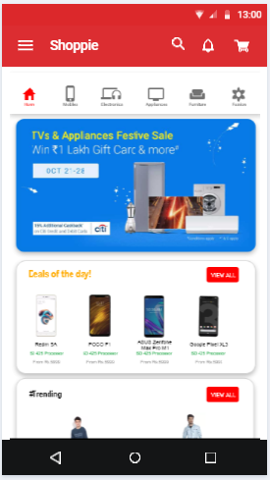 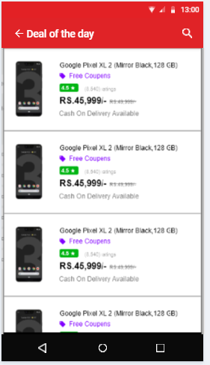



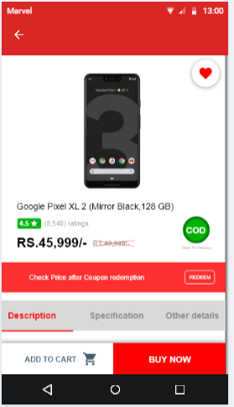 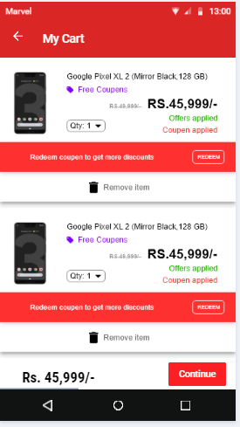



## Mapping**:**

mapping is link among command and force. One of the good example of mapping is “vertical scroll bar” It instruct to the user that where it remain appearing in a application, as user scroll it downward direction, the application goes downward side with the similar pace; by this way command and force are thoroughly mapped. Mapping contracts along with proficient towards map off measures around the link towards exactly how it perform it in actual world. For an example if a person went to the relative house for the first time and try to use the shower or microwave it all the time is always being the struggle for the person to use it. As a designer I must make every efforts to build natural design as well as events. That events thoroughly and go along the commonly recognized level. In mapping all the icons are placed clearly so that user will not get confuse and user get all the items easily.

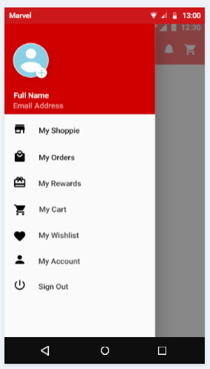

user can leave the application after signing out

This is user account from which user can go to his account

User has its own Wishlist from which user can keep his wish list items for future purchase

From my cart user can see his order which are selected

This is the menu for any gift card from the previous order

user can look at his order from my order option

this is the home to see the deals and items

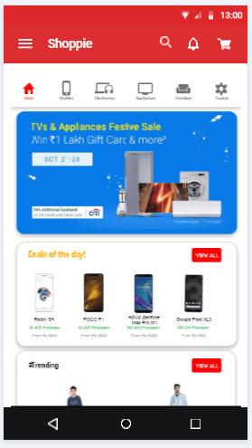



All the icons is for the different item from that user can directly go to that items and look at all the products

## Consistency:

Consistency basis on what the end user used or work on the same type of similar system before or previously that have similar version, design or gesture. this means that staying reliable and purposeful during the layout design of something, some misunderstanding continuously get removed. consistency improves develop a bond of faith among the operator as well as application or website . It is the concept of whatever they assume to occur will occur. Once the bond of faith is shattered over inconsistent layout than end-user familiarity is ruined and similarly further involves attempts upon their portion towards numbers of misdeeds(wrong doings). As below design it is seen that it is secure method for the user to do online payment and whatever the user has order will come by at user place on that date and time. By this way user 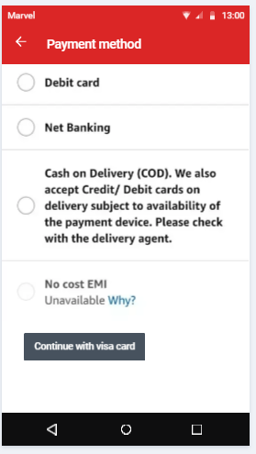trust will be there on the application. It will never goanna less user also satisfaction with the service through this process

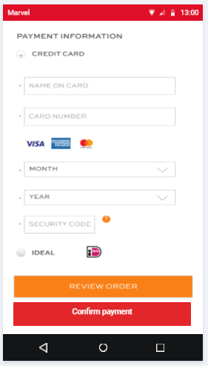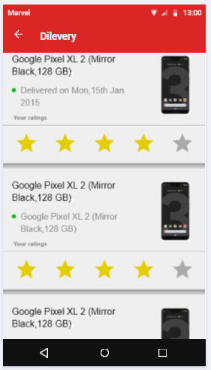

# The design can handle at least three types of human limitation /special needs:

Accessibility , usability and inclusion are strongly linked features for designing the application that will functions and meant for every individual. all the objectives , methodologies and standards and gets corresponds drastically to each other . This is the very useful to speak up with them at the same time of creating and emerging the application.

## Accessibility:

It focuses on biased characteristics related to the same operator that meant for the individual along with disabilities. Application convenience requires that the individual along with disabilities be able to uniformly recognize, identify, handle and relate through applications and devices. It furthermore requires that it can be able to provide similarly with no difficulties (Henry, 2016).

## Usability:

usability mainly aims upon individuals along with disabilities.Usability is regarding creating applications on the way to more useful, economical and fulfilling. It involves “user understanding structure” that could consist of universal attributes that effect every individual that doesn’t affect in bulk to individual along with disabilities. Adaptation procedure and study more frequent that makes not adequately focus on the requirements of individual along with disabilities (Henry, 2016).

## Inclusion:

Inclusion is concerning about variety, that confirming interest of each person to the ultimate level likely. Featuring in a few areas that is stated such as common design and design for everyone (Henry, 2016).

# **Cognitive processes how can it affect in the application:**

These days, Cognitive elements develop more vital for interaction design. It means that it implies towards anything that get into any individual brain once they perform their daily task. It includes many of cognitive procedure like reasoning, memorizing, studying and responsibility . Developer need to research about human cognitive procedure well so that it can help developer to identify the user needs. It is important for designer that designing should be of high-level element. That create communication among operators and application should be much more realistically and professional. There are basic three main elements through which cognitive process affect in the application such as memory, attention and perceptions (Linxiao, 2004).

## Memory :

It includes reminding different types of information that permit individual towards perform properly. This process is very flexible ,allowing individual to accomplish a lot of factors. For and instance this permits individual to acknowledge somebody appearance ,person name, and remind once in past when they met. This process will not work without memory. It is not likely to recall all that individual look, listen or touch. One of the process that is sorting is applied to determine which data finds more managed and remembered. short term memory has less amount of capability to organize and manage the info (MULLET, 2001). (Kostja Paschalidis, 2018).

## Attention:

Attention stands for the procedure of choosing ideas to focus on. It includes hearing and optical sensations. For an instance for hearing attention if an individual visit dentist than that individual waiting to call out his name. for an instance of optical senses individual check score of cricket match in the newspaper. Attention permits individual to concentrate on data which is important to what individual is performing .some of the highly popular rules around capturing the consideration of the client and calculating the information provided that remains crucial data is mostly better and lighter and a lesser amount of data is shorter and dull. such a way the operator be able to store that data reliant upon its impact (MULLET, 2001).

## Perceptions:

It describes that in what manner data obtained through the various organs and convert towards events of items, actions, music and flavors. This is the complicated procedure, including additional cognitive procedure like memory , attention and dialect. optical sense is extremely major feel for in-sight people, same as listening and touching. As per consideration towards interaction model, it is essential to give data in a manner such that it can be easily understood in the way as it planned (MULLET, 2001).

## Conclusion:

In conclusion as per my design It helps the user in many ways. user can use this application as pivotal part of their life . They can relay on this application easily. Now a day’s scenario change people are becoming more workaholic and busy in their life. With the few clicks and few seconds they order many things easily from online. As per all the standards my design is well fitted, and it give good output to the users as it has all the features which convenient for the user to use. It has many kind of features like application background color which attracts lots of user’s to use the application, it’s fonts style and the connections between the one page and other page is well set so that user will not get confuse and easily reach from the first to the last part of the application. All the icons are kept properly on its place and all icons are generally used in all other applications so that user has no need to search for any icons as they previously familiar with those the icons. Application is extremely crucial and useful for every user.

# Recommendation:

As per my recommendation this application Is beneficial for every age group people. This design is created for android phones so android phone user can use this application easily, as it has an attractive color background and fonts style is done better every person who has ow literacy level, they can use this easily, Because it is very simple to use. It is also helpful for the people who lives in a countryside because they are not able to such product to their nearby. It has also collaboration with multiple brands and apart from that application design is appropriate which attract the users.

# References

Carroll, John M. (2016, may 03). *Interaction design foundation*. Retrieved from interaction-design: https://www.interaction-design.org/literature/topics/human-computer-interaction

Henry, S. L. (2016, may 06). *W3c*. Retrieved from fundamentals/accessibility-usability-inclusion/: https://www.w3.org/WAI/fundamentals/accessibility-usability-inclusion/

Kostja Paschalidis. (2018, july 5). *UX collective* . Retrieved from the-application-of-cogntive-psychology-to-user-interface-design: https://uxdesign.cc/the-application-of-cogntive-psychology-to-user-interface-design-81599ad7fb55

Linxiao, M. (2004, 02 29). *Cognitive Aspects of Interaction design*. Retrieved from http://users.sussex.ac.uk/~blayw/cogint.html

MULLET, K. A. (2001, 03 12). *semantic scholar.* Retrieved from Understanding users: https://pdfs.semanticscholar.org/5e8a/f553a8f3a38fa767324ced2bd3346e7883d9.pdf

# My final design :

**The logo page of my application**

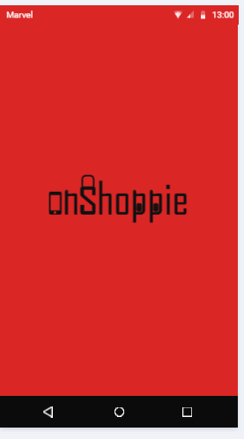

**It is the second page of my application which is sign in and registration page:**

**sign-up page:**



**Login page:**

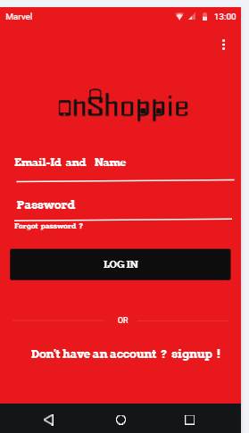

**Home page:**

**Deal of the day page:**

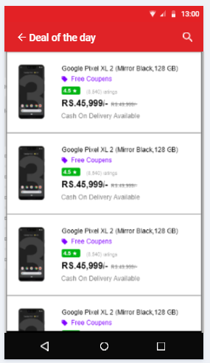

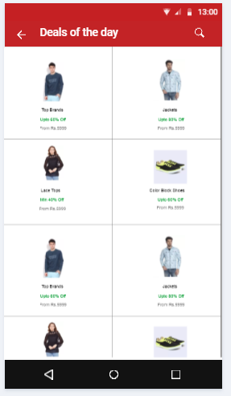

**Menu page**

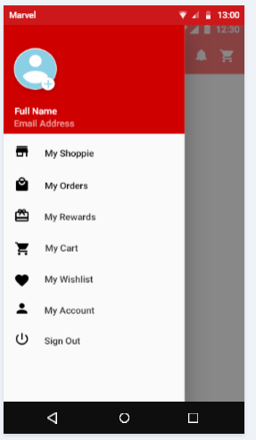

**Forget password page:**

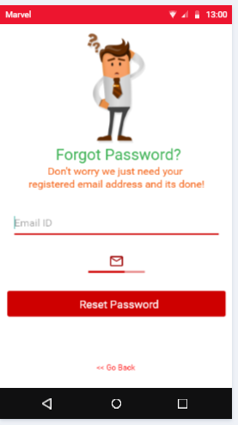

**Search icon to seach the product**



**Sign in and sign up notification for user before placing order:**

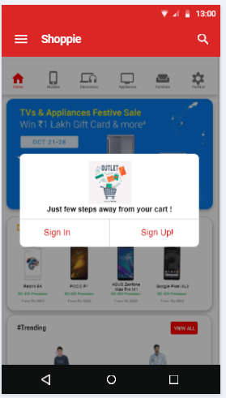

**Buy now page to see the product perfectly before buying**

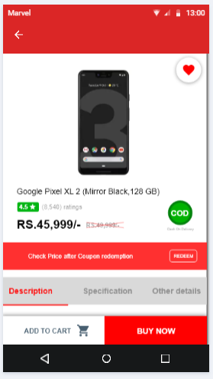

**customer can Look at all the details of the product:**

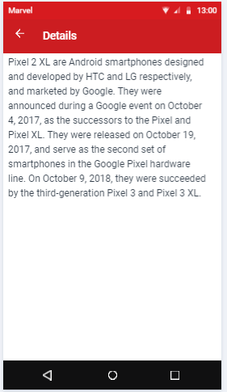

**product specification page:**

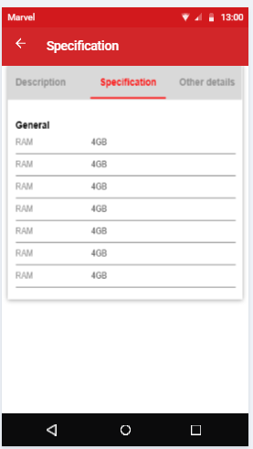

**Product description page:**

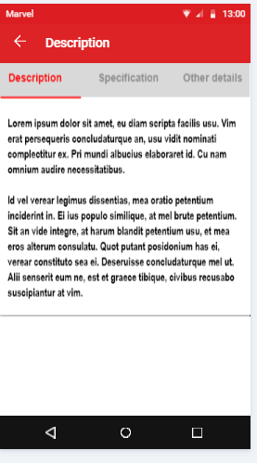

**My cart page:**

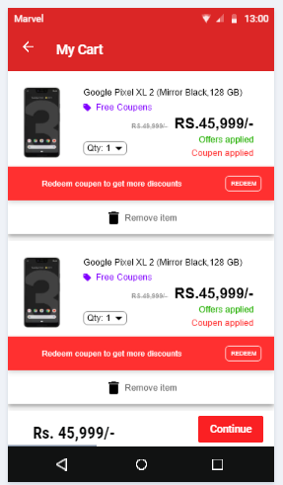

**Whishlist page:**

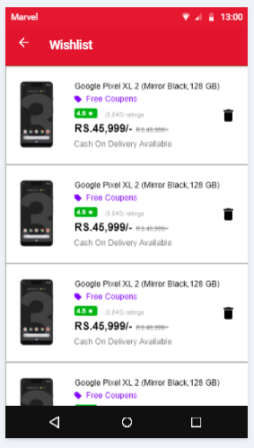

**Product delivery page:**

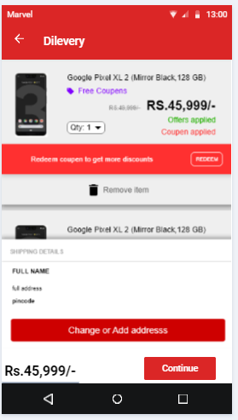

**Order details page:**

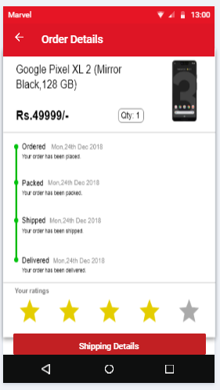

**User account page:**

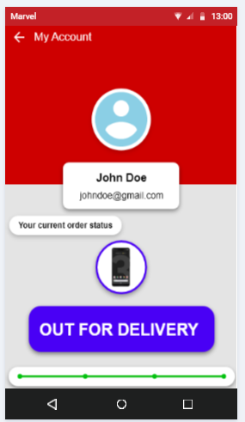

**Shipping details page**

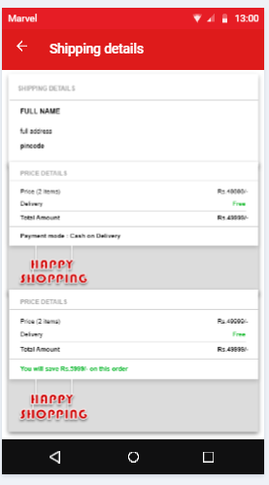

**Payment method option page:**



**Payment details page:**

